**Individual Project Report:**

**Flower Pod**

**Taylor Chevalier**

**ME 1670 – Section A**

**Summer 2021**

**Project Description**

For my Individual Project, I chose to create an artistic representation of an idea I’ve had regarding sustainable living on celestial bodies other than Earth; this Flower Pod is, essentially, a significantly smaller and more artistic version of a biodome, a structure meant to house and cultivate flora for the purpose of oxygen and food production on other planets. Of course, such an architectural feat would be significantly more complicated to produce in SolidWorks and would have taken much longer to model, so this smaller version proved more optimal. I also chose this design due to its more complex nature over my original chosen design of interlocking base and treble clefs; compared to my original first choice, the Flower Pod has more features and uses more techniques originally taught in the class, whereas the Clef Keychain would have consisted of a simple extrusion, a few revolve operations, and two fasteners. Overall, the Flower Pod allowed me to fully practice many of the operations taught throughout the course and helped develop a better sense of intuition regarding how to use CAD software to present ideas.

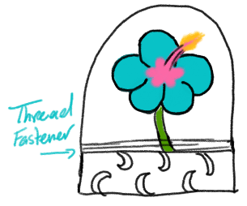

*Figure 1: Sketch of assembled Flower Pod*

The basic design of the flower pod consists of three interlocking parts: a decorative base, a dome, and a flower. The dome was designed to completely house the flower, “protecting it from harm,” in a metaphorical sense. It also has a keyring on top to hang from a bag if desired. The base consists of a hollowed octagonal prism with a post in the center to hold the lower in place. The flower itself is a simple cylinder with another octagonal prism and eight staggered petals created using the Boundary Boss feature. The flower also contains a threaded Extrude Cut at the bottom, where it screws into the base

Note that these preliminary sketches have several differences compared to the final product. Many of these differences came from understanding the use of SolidWorks as a medium of production; some of the features had to be altered in order to achieve the overall idea, such as decoration and practicality of fasteners (this will be further discussed in Design for Manufacturing Considerations).

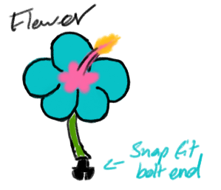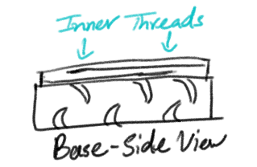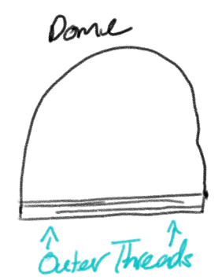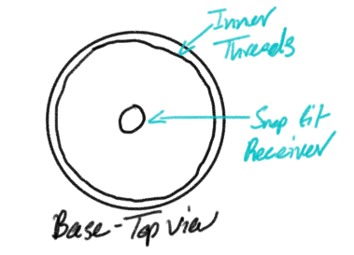

*Fig. 2: Sketches for individual parts*

**CAD Features**

# Design for Manufacturing Considerations

Describe how you went about designing your part. Please do not simply provide a description of the CAD operations – focus instead on how the specific part dimensions were chosen, any intermediate variations of the part models, and any other factors you have considered. Some questions you should address in this section are:

* + How did you decide what kind of interlocking feature to use? What types of designs did you select from (e.g., threaded, slip fit, lip on edge, etc.).
  + What resources did you use to design the interlocking feature?

# Discuss the specific tolerance values you’ve selected for the interlocking features and why. If no tolerances were used, explain why.

* + What were the choices you made in your design specifically for ease of manufacturing/ 3D printing?
  + Were there areas that were likely to be problem areas for manufacturing the design? How did you try to address these potential problems with your design choices?
  + Was your design based on something you have seen before? Include references for any information you used to help design your part. If you based it on a part on Thingiverse, even if it was just inspiration, include a reference. If it is a commercial product, include a reference too. For example, how did you know what size and shape to make your gear teeth? How were gear ratios calculated?
  + How much iteration/trial and error did it take to reach the desired CAD models?
  + Did you utilize the CAD assemblies to troubleshoot your design?
  + Provide a few snapshots of the intermediate CAD models (if available) and describe your thought/modeling process

Part 1 –

Model #1



Assembly 1

Part 1 –

Model #2



Final Design

Part 2 –

Model #1



Part 2 –

Model #2



*Figure #: Intermediate CAD models (inserted as pictorial images). Under each image include a name for it and in the paragraph above be sure to describe what you learned from it, why it was created, and how it was changed for the next iteration.*

# Challenges Faced in Manufacturing

Describe your experience with 3D printing and/or assembling your design. You should address some of the following points in this section:

* + Describe any difficulties you have faced with manufacturing your parts (what turned out, what didn’t)
  + Describe any difficulties you have faced assembling the manufactured parts into the final design
  + What would you change in your CAD models in order to address these difficulties?
  + How could you speed up this design process or make it more efficient in the future?
  + What did you learn about the differences between nominal or “ideal” dimensions in your CAD model vs. real dimensions that result from manufacturing processes?
  + How could you as a designer use these lessons in the future when you design parts?

# Tolerance Analysis

In table form **and also paragraph form**, describe and discuss the differences in dimensions between the CAD files and the 3D printed parts – i.e. tolerance analysis. Focus on the dimensions that are most important for the part and its functionality (e.g., interlocking features, overall dimensions)

|  |  |  |  |
| --- | --- | --- | --- |
| Feature | Dimension in CAD | Actual Measured on  3D part (use calipers) | % difference |
| *Feature #1* | ##.## | ##.## | ##.## |
|  |  |  |  |
|  |  |  |  |
|  |  |  |  |
|  |  |  |  |

*Table #: Final Design’s Dimensions*

# Conclusions

In paragraph form, describe how your design evolved from its initial state to its final state. Describe the most important thing you learned in doing this project.

**CAD Drawings**

* + Assembly drawing of your design (bill of material, exploded views, etc. are not required, but can be added)
  + Fully dimensioned drawing of each separate component
  + Utilize best practices for dimensioning, views, and layout in CAD drawings

# Use the 1770 template for all drawings (including assembly) Appendix - Additional materials as needed